MIT Assignment-10

Jeetu Mehra
U24AI032
• Given are two numbera. Using 8086 instruction set

Q1:
Add, substract the given numbers CODE:
; You may customize this and other start-up templates;
; The location of this template is c:\emu8086\inc\0_com_template.txt

org 100h

MOV AL, 25H ; 1st number
MOV BL, 15H ; 2ND number

; ADD
MOV AH, AL
ADD AH, BL ; AH = AL + BL

; SUB
MOV CL, AL
SUB CL, BL ; CL = AL - BL

ret
OUTPUT:
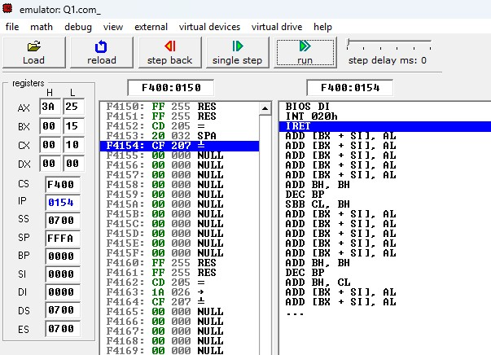
Q2:
Convert the numbers into ASCII
CODE:

org 100h

MOV AL, 25 ; Number to convert (decimal 25) -> ASCII
MOV BL, 10 ; Divisor

; Convert number in AL to ASCII
XOR AH, AH ; Clear AH for DIV
DIV BL ; AL / 10 -> Quotient in AL, Remainder in AH
ADD AL, '0' ; Convert quotient to ASCII, stored in AL
ADD AH, '0' ; Convert remainder to ASCII, stored in AH

; Now:
; AL = ASCII of tens digit
; AH = ASCII of units digit

ret

OUTPUT:
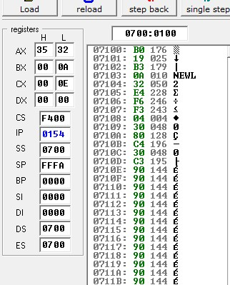
Q3:
Add 47H to output of addition. If a carry is generated then display FFH else display 00H in register CX.
CODE:
org 100h

MOV AL, 25H ; 1st number
MOV BL, 15H ; 2nd number

; ADD
MOV AH, AL
ADD AH, BL ; AH = AL + BL

; --- Add 47H and check carry ---
MOV AL, AH ; Load addition result
ADD AL, 47H ; Add 47H
JC carry_flag ; Jump if carry generated

; --- No carry ---
MOV CX, 0000H ; Set CX = 0000H if no carry
JMP done

carry_flag:
MOV CX, 0FFFFH ; Set CX = FFFFH (FFH) if carry

done:
ret

ret

OUTPUT:
